## horizontal line



**Financial Modelling I - Final Project Report**

**─**

Weiwei Kong

Shrinidhi Ghatpande

Prasham Parekh

Venkatesh Jain

# **Introduction**

In this portfolio investment project, our group was given a notional $1 million to invest over a period of 15 weeks. The investment universe was restricted to the 30 stocks in the Dow Jones Industrial Average (DJIA) and the 3-month Treasury bill. We were allowed to use short sales and margin trading to implement our investment strategy.

To simulate the costs of trading, we assumed a one-way transaction cost of 20 basis points for trading stocks. That is, for each buy or sell transaction of a stock, we incurred a cost of 0.2% of the transaction value.

Our trading frequency was once a week, specifically every Friday. This means that we could adjust our portfolio holdings every week based on our evolving investment outlook. We were free to use any investment strategy that we deemed appropriate, as long as it complied with the project guidelines and the principles of sound investment management.

Throughout the project, we aimed to construct a portfolio that would achieve our investment objectives while managing risk effectively. We employed mostly a factor investment strategy.. We also monitored market trends and news developments to stay informed about market conditions.

Overall, this project provided us with a valuable opportunity to apply the concepts and tools of investment management in a practical setting. We hope that our project report will provide insights into our investment strategy and performance, and contribute to our understanding of portfolio management.

# 

# **Choice of Strategy**

Momentum trading is a popular strategy in the stock market that involves buying stocks that have shown a consistent upward trend in price over a certain period, typically 3 to 12 months. The strategy is based on the findings that stocks that have performed well in the recent past are likely to continue to perform well in the near future.

The *alpha* of the momentum strategy is a well-known and well-documented anomaly in the efficient market hypothesis. Dr. Cliff Asness reported the anomaly in his Ph.D. dissertation at the University of Chicago. Many traders and academics have tested and added components (factors) to this finding ever since.

The variation we chose to implement for our project was the one proposed by Luca Giusti in the book *A Portfolio for the Investors* (the original book is in Italian). We backtested the strategy over two years of performance in which it generated more returns compared to the benchmark index, DJIA, in this project's case.

The original strategy involved selecting momentum stocks from the pool of the NASDAQ 100 index. We limited our pool to the components of DJIA as required for the project. Our selection process began by choosing the top 50% of stocks with the highest returns over the past 12 months. We selected the top 30% of stocks with the best performance over the past 6 months. We narrowed our selection to the top 10% of stocks that exhibited the most returns over the past 3 months. We repeated this filtration process every month, and our backtesting showed that the overall returns of our selection were higher compared to the benchmark index, DJIA, over the two years of our analysis.

We made the following key assumptions for our trading activities: the transaction costs are 0.02% and every $1 in the short position gives us a $0.50 in additional float in our long position. As mentioned earlier, the pool of stocks is limited to the DJIA components and the 3-month t-bill. We traded every Friday and assumed that closing prices for stocks were realized i.e. no slippages in trading. For our equity positions, we used equal weights.

# 

# **Changes to the Trading Strategy**

The text describes some changes that were made to a trading strategy that was originally intended to be adopted as described in a book. Due to the specific rules of the project, modifications were necessary in order to comply with them.

The first modification was related to the choice of stocks that were used as a base pool for the strategy. Instead of using a different set of stocks, the DJIA (Dow Jones Industrial Average), constituents were selected as the base pool.

The second modification was to the frequency at which stocks were filtered. Instead of filtering on a monthly basis as the book suggested, filtration was done on a weekly basis.

Lastly, a long-short approach was introduced towards the end of the project to help cope with losses that were sustained earlier in the project. This approach involves simultaneously buying and selling stocks in order to profit from the differences in their prices and can be used to hedge against market risk or to profit from market inefficiencies.

# 

# **Performance of the Strategy**

Throughout the course of this project, we traded 15 out of 30 stocks in the DJIA. Although, we held at most 6 stocks both long and short at any one instance, we

### Returns of the strategy:

This is how our strategy performed when compared with Dow Jones Industrial Average. Frankly speaking, DJIA makes nearly zero profits in these 3 months. When considering our strategy, as the graph shows, because the trading frequency is weekly, we simply utilize the discrete tracking system. One sad thing is that we lose around 11 percent of our capital, which is not a good performance in 3 months.

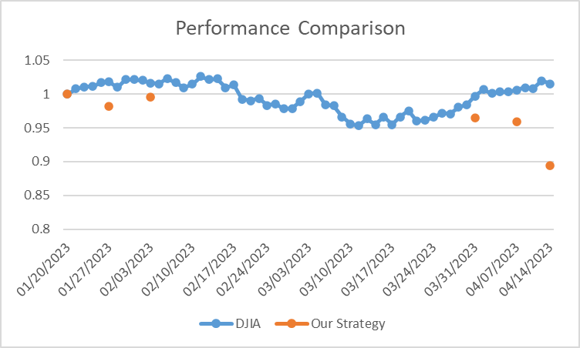

### 

### 

### 

### 

### 

### 

### 

### Key Ratios:

|  |  |
| --- | --- |
| Statistic | Figure/comment |
| 1. Portfolio Mean Return | -0.0073 |
| 2. Standard Deviation | 0.0635 |
| 3. T-ratio of Mean Return | 0.0170 (statistically insignificant) |
| 4. Excess return over the T-Bill | -0.1524 |
| 5. t-statistic of excess returns over t bill | 0.016 (statistically insignificant) |
| 6. Excess return over the DJIA | -10.16% (statistically insignificant) |
| 7. Sharpe Ratio | -0.34 |
| 8. Market Beta | -0.3875 |
| 9. Market Alpha | -0.0625 |
| 10. Treynor Measure | 0.1384 |
| 11. M2 Measure | 0.0953 |
| 12. Appraisal Ratio | -0.125 |
| 13. Best weekly return | 0.1021 |
| 14. Worst weekly return | -0.1202 |
| 15. Number of winning weeks | 4 |
| 16. Number of losing weeks | 9 |
| 17. Maximum consecutive losing weeks | 3 |

# 

# **Key Reasons Behind Underperformance**

The 11 percent loss is not scary, the key is that we need to learn from this. The bloody lesson that we have got from our trading scenarios is listed as below:

1. Market Turbulence

The main culprit behind this is we paused all our trading activities trading for around 2 months, and during that time, the market is so volatile, along with the bankruptcy of SVB.

1. Pain Positions

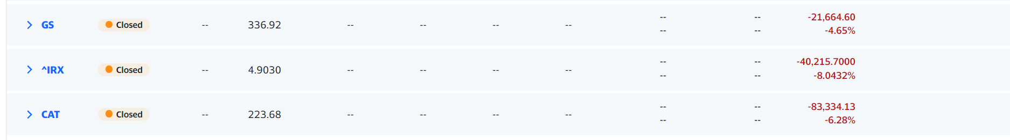

Here we listed the 3 most non-profitable assets in our trading portfolio, take a brief look at it, and do a simple calculation, the loss was around 145k, which has been effective enough to explain our losses. Due to the increasing interest policy by the Fed, many banks suffered from a huge loss, the merge & acquisition of Credit Suisse, this has been a typical event driven market at that time, so the momentum strategy will not be as efficient as before.

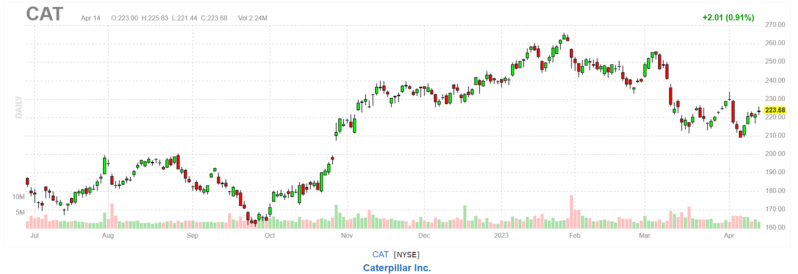

One more thing that we want to point out is the stock Caterpillar because of its biggest loss, we hold Caterpillar at the beginning of the February, and did not implement any trading for almost 2 months, simply sold it in the late March, as the candle graph of CAT shows, there was an approximately 25 dollars per share loss, which was what really crashed us.

1. A shift in correlations

The picture below shows the correlation in the first 7 weeks.

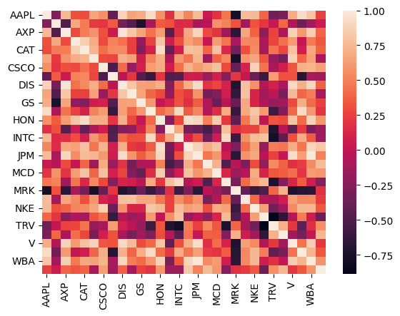

Volatility increased in the market after 10 March 2023 which can be seen from the graph. Correlations went from evenly distributed to mostly positively distributed.

The following diagram shows how the correlation presents in the last 7 weeks.

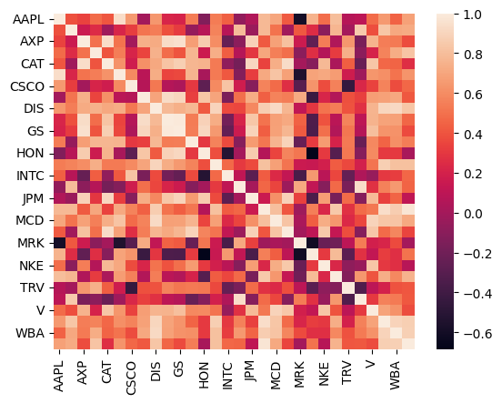

# **Theoretical Performance**

As one of the reasons behind the underperformance is not implementing the strategy rigidly, we can see that we missed the strategy’s backtested returns. Below are the potential returns that we missed.

### Performance of the long/short approach (backtested)

A long-short variation of the momentum strategy would have returned ~3% in the duration of our project. As opposed to a minor loss returned by the DJIA. In the graph below, we can see the exact date when the correlations of the DJIA stock returned shifted towards positive side resulting in the losses in short positions.

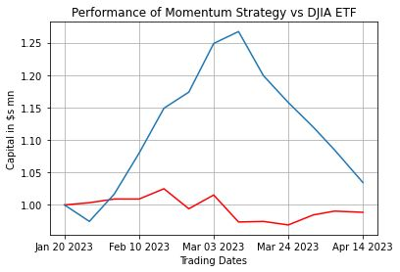

### Performance of the long-only approach with monthly filtration (backtested)

A long only/vanilla version of the momentum strategy would have returned a decent return of about 13% in the same period. There seems to be some alpha generation with returns exceeding those of the DJIA itself, However, we cannot speak about the statistical sanity of these returns.

|  |  |
| --- | --- |
| Date | Returns |
| 1/31/2023 | 1.0000 |
| 2/28/2023 | 1.0216 |
| 3/31/2023 | 1.1428 |
| 4/30/2023 | 1.1348 |

# 

# **Conclusions**

Our portfolio lost nearly $145 thousand dollars in the duration of this project whereas the plain vanilla implementation as well as the long-short modification with weekly filtration generated decent gains.The primary reason for the portfolio loss was the market turbulence which occurred due to a two-month trading pause and the bankruptcy of SVB. The three most unprofitable stocks in the portfolio caused a loss of around $145k. The increasing interest policy by the Fed and the failure of Credit Suisse led to many banks suffering huge losses. The holding of Caterpillar at the beginning of February caused a significant loss of approximately $25 per share. A shift in correlations occurred after March 10, 2023, leading to increased market volatility and mostly positive correlations.

Another reason for this underperformance is our imperfect understanding of the momentum factor strategy itself. We now understand that backtesting a strategy over recent past is not sufficient. We need to take into account the statistical sanity of the data and the strategy before we act upon any investment decision.

For future portfolio management exercises, we shall keep these lessons in our mind always.